**Question.**

**Design a system that automatically turns on the lights inside an almirah whenever it is opened, (irrespective of day/night).**

**Circuit Diagram**

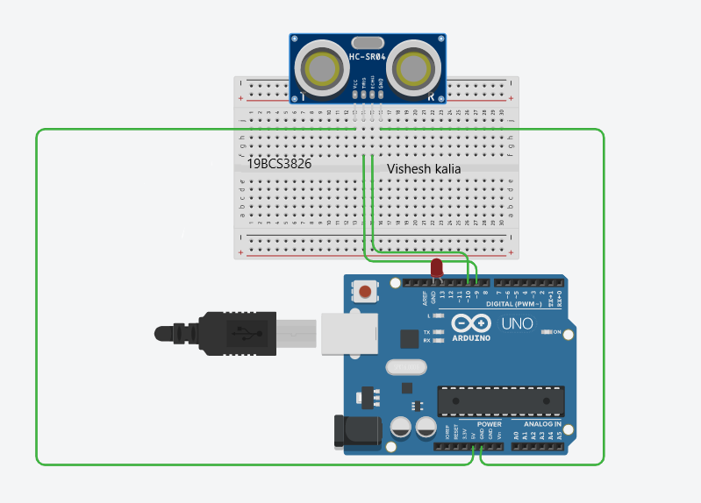

**Theory**

**Concept used:**

We had to design an system that automatically turns on the lights inside an almirah whenever it is opened (irrespective if day/night).So using ultrasonic sensor we place the system inside the almirah in such a way that when we open the almirah the distance between the obstacle(which was initially door of the almirah) and the system increases, now we have written the code for this system in such a way that when the distance becomes greater than 80cm (letting the distance between the system and the door of almirah when closed to be 80 cm) the led inside the almirah starts glowing.

**Learning and observations:**

We got to learn about the working of Arduino and Ultrasonic Sensor. We get to know that how to make connections of ultrasonic sensor with arduino.

**Problems and Troubleshooting:**

The main problem in this question was that how to make connections in a write way so that the led glows as required.

Another problem was with the code of this experiment and how to make the led glow with the increase in distance.

**Precautions:**

1. Making the connections in breadboard correctly.

2.Making the connections of trigger,echo,ground and Vcc correctly.

3. Making sure that there is no mistake in the code.

**Learning outcomes:**

We got to learn about the working of Arduino and Ultrasonic Sensor. We get to know that how to make connections of ultrasonic sensor with arduino.

Skills earned by means of this experiment-

1. My coding regarding arduino and ultrasinuc sensor got better.
2. Better skills in making connections of breadboard with arduino.